

Assignment 1

Design

Pattern

Submitted By:

* Hozefa Hassan Rizvi (FA20-BSE-019)
* Muhammad Adeel (FA20-BSE-163)

Submitted To:

* Sir Mukhtiar Zamin

Assignment 1

**Title:**

* Parental Educational Management System (PEMS)

**Introduction:**

The **Parental Education Management System (PEMS)** is an innovative Java NetBeans console application designed to create a seamless bridge between parents and their children's educational journey. This system provides a secure platform for parents to monitor their child's academic progress, communicate with teachers, and address any concerns in a timely and efficient manner.

**Features:**

1. **Secure Authentication:** Ensures the privacy and security of sensitive information by allowing only authorized access to the system.
2. **Comprehensive Student Profile:** Displays detailed information about the child, including name, class, registration number, phone number, gender, and the name of the class teacher.
3. **Real-time Communication with Observer Pattern:** Enables seamless and real-time communication between parents and teachers, ensuring instant updates on the child's progress or any concerns.
4. **Progress Tracking:** Provides insights into the student's academic performance, including marks in different subjects, overall percentage, and position in the class.
5. **Teacher Information:** Presents the names of teachers for all subjects and the class teacher, enhancing communication and understanding between parents and teachers.
6. **Meeting Scheduler with Class Teacher:** Facilitates the scheduling of meetings with the class teacher, checking the teacher's availability, and enabling real-time chat sessions through socket programming.
7. **Complaint Monitoring and Resolution with Template Method Pattern:** Allows parents to view and approve complaints raised by teachers, ensuring transparency and efficient resolution using a predefined template method.
8. **Flexible Object Construction with Builder Pattern:** Ensures flexibility in constructing complex objects with varying representations, facilitating the dynamic creation of student and teacher profiles.
9. **Adaptable System Design with Strategy Pattern:** Allows the system to adapt according to changing environmental needs and requirements, ensuring its sustainability and flexibility over time.

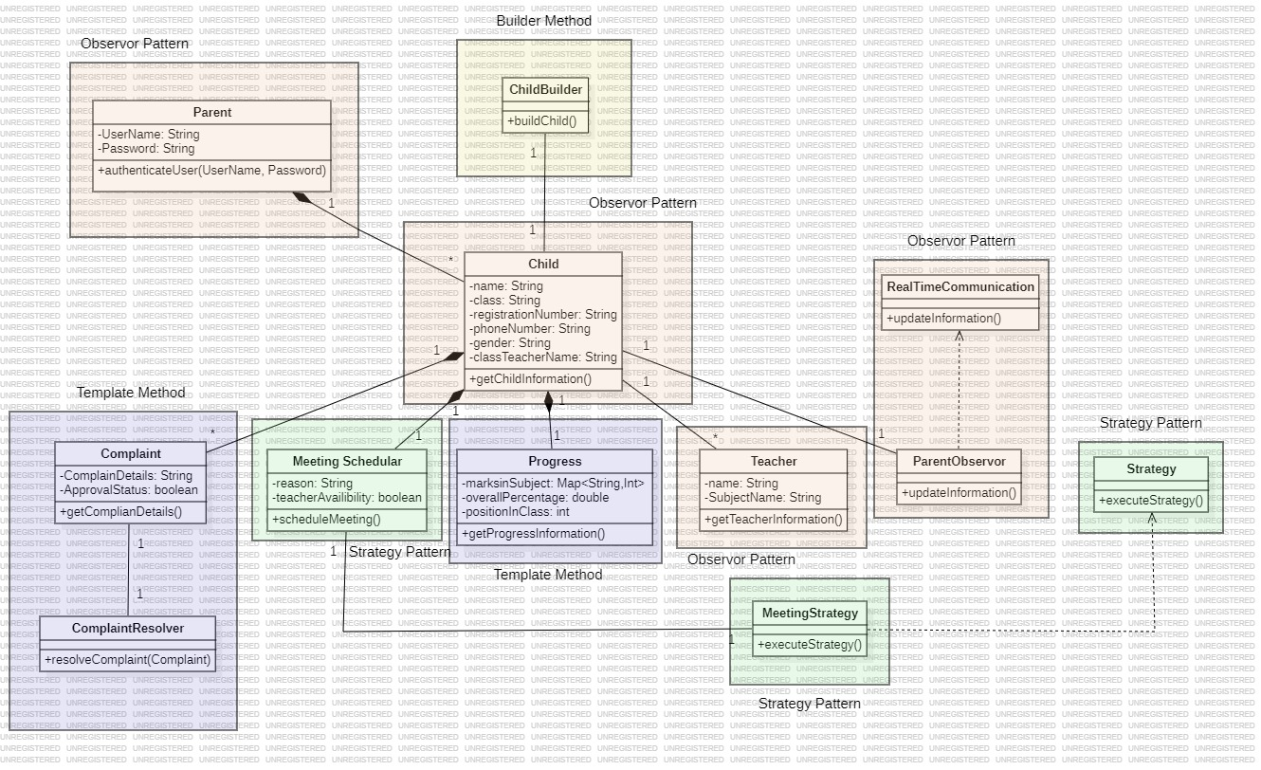**Class Diagram:**

**Explanation of each Class:**

1. **ParentObserver (Observer Pattern):** Facilitates real-time communication between parents and teachers, allowing parents to stay updated about their child's progress and any necessary actions.
2. **Complaint (Template Method Pattern):** Represents the complaints raised by teachers or children. It utilizes the Template Method pattern to define the steps for setting and getting complaint details.
3. **ComplaintResolver (Template Method Pattern):** Handles the resolution of complaints. It uses the Template Method pattern to define the steps for resolving complaints, ensuring a consistent process for resolving different types of complaints.
4. **MeetingStrategy (Strategy Pattern):** Provides strategies for scheduling different types of meetings. The Strategy Pattern allows for the dynamic selection of meeting strategies depending on various factors and requirements.
5. **ChildBuilder (Builder Pattern):** Constructs the Child object, separating the construction process from its representation, ensuring the same construction process can create different representations of a Child object.
6. **Parent:** Represents a parent and includes attributes like userName, password, and childrenRegistrationNumber. It facilitates parent authentication and information retrieval.
7. **Child:** Represents a child and includes attributes such as name, className, registrationNumber, and phoneNumber. It provides functionality to retrieve child information.
8. **Progress:** Represents the progress information of a child, including marksInSubjects, overallPercentage, and positionInClass. It might utilize the Template Method pattern for specific calculation methods related to a child's progress.
9. **Teacher:** Represents a teacher and includes attributes such as name and subjectName. It provides functionality to retrieve teacher information.
10. **MeetingScheduler:** Manages the scheduling of meetings between parents and teachers. It might utilize the Strategy Pattern for scheduling different types of meetings based on various strategies.